


Higher Nationals in Computing

Unit 30: Application Development
ASSIGNMENT 2

Learner’s name: Huynh Cam Hung
ID: GCS18026
Class: GCS0701A
Subject code: 1670
Assessor name: LE NGOC THANH

Assignment due: 10 May 2020 Assignment submitted: 10 May 2020
ASSIGNMENT 2 FRONT SHEET
Qualification | BTEC HND Diploma in Computing and Systems Development
Unit number and title | Unit 30: Application Development
Assignment due | 10 May 2020 | Assignment submitted | 10 May 2020
Learner’s name | Huynh Cam Hung | Assessor name | Le Ngoc Thanh

Learner declaration:
I certify that the work submitted for this assignment is my own and research sources are fully acknowledged.
Learner signature |  | Date

Grading grid
P3 | P4 | P5 | M3 | M4 | D3 | D4

Assignment title | Assignment 2: Application Implementation and Evaluation
In this assignment, you will have opportunities to provide evidence against the following criteria.
Indicate the page numbers where the evidence can be found.

Assessment criteria | Expected evidence | Task | Assessor’s Feedback
LO3: Work individually and as part of a team to plan and produce a functional business application with support documentation

P4 Create a formal questionnaire that effectively reviews your business application, problem definition statement, proposed solution and development strategy. Use this questionnaire as part of a peer-review and document any feedback given. | - Questionnaires to peer-review your application | 1
P5 Develop a functional business application based on a specified business problem | - A runnable implementation of the application
LO4: Evaluate the performance of a business application against its Software Design Document and initial requirements
P4. Review the performance of your business application against the Problem Definition Statement and initial requirements. | 3. Test plan  4. Test results | 3

Assessment criteria |  | Expected Evidence | Feedback  (note on Merit/Distinction if applicable)
Merit descriptor No. (M3)
Merit descriptor No. (M4)
Merit descriptor No. (M5)
Distinction descriptor No. (D2)
Distinction descriptor No. (D3)
Summative feedback

Assessor’s Signature |  |  |  | Date

Unit Number and Title | 30: Application Development
Academic Year | 2018
Unit Tutor | To Hoai Viet
Assignment Title | Assignment 2: Application Implementation and Evaluation
Issue Date
Submission Date | 10 May 2020
IV Name & Date

Learning Outcomes and Assessment Criteria
Pass | Merit | Distinction
LO3 Work individually and as part of a team to plan and produce a functional business application with support documentation |  | D2 Evaluate any new insights, ideas or potential improvements to your system and justify the reasons why you have chosen to include (or not to include) them as part of this business application.
P4 Create a formal questionnaire that effectively reviews your business application, problem definition statement, proposed solution and development strategy. Use this questionnaire as part of a peer-review and document any feedback given.  P5 Develop a functional business application based on a specified business problem. | M3 Interpret your peer-review feedback and identify opportunities not previously considered.  M4 Develop a functional business application based on a specific Software Design Document with supportive evidence of using the preferred tools, techniques and methodologies.
LO4 Evaluate the performance of a business application against its Software Design Document and initial requirements
P6 Review the performance of your business application against the Problem Definition Statement and initial requirements. | M5 Analyse the factors that influence the performance of a business application and use them to undertake a critical review of the design, development and testing stages of your application. Conclude your review by reflectively discussing your previously identified risks. | D3 Critically evaluate the strengths and weaknesses of your business application and fully justify opportunities for improvement and further development.

Assignment Brief and Guidance
As the technology is being developed rapidly nowadays, FPT Co. desires to build the continuing study environment throughout the corporation. It is necessary to develop a web-based system, which manages the activity of “Training” for internal training program of the company. This system can be used to manage trainee accounts, manage trainers, manage course categories, manage courses, manage topics, assign topic to course, assign trainer to topic, assign trainee to course.
This is a system used by HR department. We have three roles in this system, an administrator, training staff and a trainer. The brief description of those roles is as follow.
- An administrator’s role
  - Can login to the system through the first page of the application
  - Can create/edit/delete new user account for trainer/training staff and assign/change(if existing user) username and a password
- A training staff’s role
  - A registered training staff, who is assigned a user name and a password by the administrator logs in can create trainee accounts by entering details like trainee name, trainee accounts, age, date of birth, education, main programming language, TOEIC score, experience details, department, location, etc.
  - After entering successfully all details for trainees, his/her details are then stored in the database. The training staff is given a list of trainees for him to view and search. From the list of trainees, he can also search by trainee account, programming language, TOEIC score…
  - Can update, delete trainee accounts
  - Can manage course categories such as searching, adding, updating and deleting course categories. Course category includes the information such as course category name and descriptions.
  - Can manage courses such as searching, adding, updating and deleting courses. Course includes course name and description.
  - Can add topics such as topic name and topic descriptions into a course, add courses into a category.
  - Can manage trainer profile such as adding, updating and deleting the information: Trainer name, External or Internal Type, working place, telephone, and email address.
  - Can assign trainer to a topic.
  - Can assign trainee to a course.
- A trainer’s role
  - In the same system, the trainer who have been registered by the administrator can login and can update his profile such as Trainer name, External or Internal Type, education, working place, telephone, and email address.
- Can view courses which have a topic he is assigned to.

Your manager suggests that this would be a great opportunity for you to demonstrate your capabilities by designing and developing the application. After considering, you decide to do the project. The project consists of 4 steps which is divided into two phases. After two first steps of analysing and designing the solution, now it is time to implement and evaluate the application.
Assignment Guidance
Task | Assessment Criteria | Requirement
1 | P4 Create a formal questionnaire that effectively reviews your business application, problem definition statement, proposed solution and development strategy. Use this questionnaire as part of a peer-review and document any feedback given. | - Questionnaires to peer-review your application
2 | P5 Develop a functional business application based on a specified business problem. | - A runnable implementation of the application
3 | P6 Review the performance of your business application against the Problem Definition Statement and initial requirements. | - Test plan  - Test results
4 | M3 Interpret your peer-review feedback and identify opportunities not previously considered. | - Peer-review feedback and Evaluation on feedback  - Recommendation for improvements
5 | M4 Develop a functional business application based on a specific Software Design Document with supportive evidence of using the preferred tools, techniques and methodologies. | - Sequence diagrams to show business process of important application functions
6 | M5 Analyse the factors that influence the performance of a business application and use them to undertake a critical review of the design, development and testing stages of your application. Conclude your review by reflectively discussing your previously identified risks. | - Evaluation on test results
7 | D2 Evaluate any new insights, ideas or potential improvements to your system and justify the reasons why you have chosen to include (or not to include) them as part of this business application. | - A presentation about your application
8 | D3 Critically evaluate the strengths and weaknesses of your business application and fully justify opportunities for improvement and further development. | - Evaluation of your application in the presentation

Submission Format
The submission is in the form of documents/files:
1. A report document including required evidences
2. An installable and executable version of your application (P5)
3. A presentation if necessary (D2, D3)
You are required to make use of headings, paragraphs, subsections and illustrations as appropriate, and all work must be supported with research and referenced using the Harvard referencing system.

Table of content
1. Questionnaire for peer-review 1
1.1. Questions 1
1.2. Result 3
2. Application models 3
3. Application controllers 10
3.1. AdminController 11
3.2. StaffController 16
3.3. StaffCategoryController 18
3.4. StaffCourseController 23
3.5. StaffTopicController 30
3.6. StaffTrainerController 35
3.7. StaffTraineeController 36
3.8. StaffProfileController 41
3.9. TrainerController 42
3.10. TraineeController 45
3.11. HomeController 46
4. Application interfaces 48
4.1. Login page 49
4.2. Login as Admin 50
4.3. Login as Training Staff 53
4.4. Login as Trainer 69
4.5. Login as Trainee 72
5. Review performance 75
5.1. Test plan 75
5.2. Test result 80
References 85

- Questionnaire for peer-review
  - Questions
1/ Would you think that the application could meet all the user requirements?
- Yes
- No
- Other
2/ If these are requirement not meet, what requirement of which roles are not meet? (You could select multiple answers)
- Admin
- Training Staff
- Trainer
- Trainee
3/ What rate would you give for the solutions of the application for the requirement?
- Very good
- Good
- Medium
- Bad
- Very bad
4/ What rate would you give for the interface of the application?
- Very good
- Good
- Medium
- Bad
- Very bad
5/ Would you think the application need for improvement?
- Yes
- No
- Other
- What roles solution need to be improved? (You could select multiple answers)
- Admin
- Training Staff
- Trainer
- Trainee
  - Result
After conducting the questionnaire to peer-review, I have the following conclusion:
1/ The application meet the requirements of user requirement.
2/ The solutions and interfaces of the application rating is medium in average.
3/ The Training Staff solutions is considered need for improvement.
- Application models
The application includes 10 models:
No | Models | Description
1 | Account | The model contains attributes of login accounts.
2 | User | The model contains basic attributes of all roles included in the system. The model is used for other role to inherit its attributes.
3 | Staff | The model contain the attributes of Training Staff.
4 | Trainer | The model contain the attributes of Trainer.
5 | Trainee | The model contain the attributes of Trainee.
6 | Subject | The model contains basic attributes of Category, Course, and Topic included in the system. The model is used for other class to inherit its attributes.
7 | Category | The model contain the attributes of Category. It inherits attributes from Subject model.
8 | Course | The model contain the attributes of Course. It inherits attributes from Subject model.
9 | Topic | The model contain the attributes of Topic. It inherits attributes from Subject model.
10 | CourseDetail | The model contain the foreign relationships with Course, Topic, and Trainer.

- Account
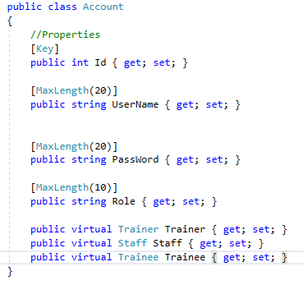

- User
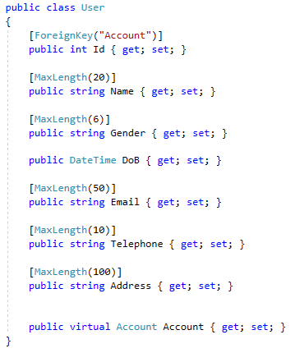
- Staff
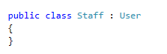

- Trainer
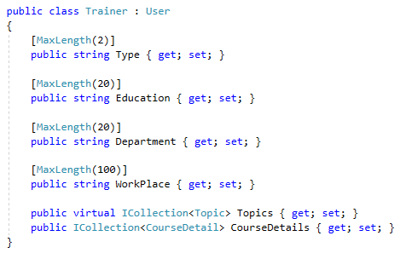

- Trainee
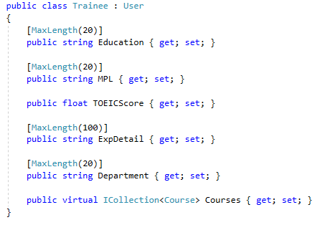
- Subject
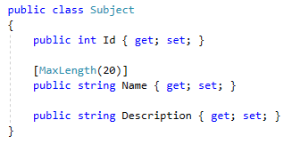

- Category
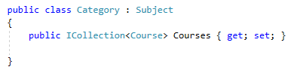
- Course
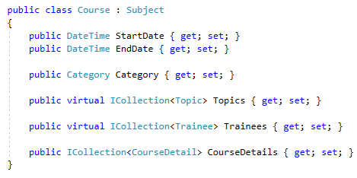
- Topic
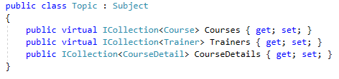
- CourseDetail
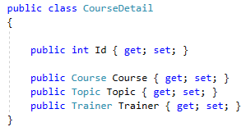
- Application controllers
The system includes 11 controllers:
No | Controllers | Description
1 | AdminController | The controller take in charge all of functions when user login as Admin.
2 | StaffController | The controller take in charge some basic functions when user login as Training Staff. The controller is used to inherit by other controller related to Training Staff.
3 | StaffCategoryController | The controller take in charge all of functions about Category when user login as Training Staff.
4 | StaffCourseController | The controller take in charge all of functions about Course when user login as Training Staff.
5 | StaffTopicController | The controller take in charge all of functions about Topic when user login as Training Staff.
6 | StaffTrainerController | The controller take in charge all of functions about Trainer when user login as Training Staff.
7 | StaffTraineeController | TThe controller take in charge all of functions about Trainee when user login as Training Staff.
8 | StaffProfileController | The controller take in charge all of functions about Training Staff profile when user login as Training Staff.
9 | TrainerController | The controller take in charge all of functions when user login as Trainer.
10 | TraineeController | The controller take in charge all of functions when user login as Trainee.
11 | HomeController | The controller take in charge all of functions for login and log out of the application.

  - AdminController
[Authorize]
public ActionResult DeleteAccount(int id, string role = "All", string search_name = "")
{
CheckRole();

Account account = db.Accounts.Find(id);

string r = account.Role;

switch (r)
{
case "Admin":
break;
case "Staff":
Staff staff = db.Staffs
.Where(s => s.Account.Id == id)
.FirstOrDefault();
db.Staffs.Remove(staff);
break;
case "Trainer":
Trainer trainer = db.Trainers
.Where(tr => tr.Account.Id == id)
.FirstOrDefault();
db.Trainers.Remove(trainer);
break;
case "Trainee":
Trainee trainee = db.Trainees
.Where(tr => tr.Account.Id == id)
.FirstOrDefault();
db.Trainees.Remove(trainee);
break;
default:
break;
}
db.Accounts.Remove(account);
db.SaveChanges();

return RedirectToAction("Index", "Admin", new
{
id = id,
role = role,
search_name = search_name
});
}
[Authorize]
public ActionResult AddNew(string username, string password, string repassword, string role)
{
CheckRole();

Account account = db.Accounts.Where(a => a.UserName == username).FirstOrDefault();

if(account != null)
{
TempData["result"] = "The username is already exist!";
return RedirectToAction("AddNewInterface", "Admin");
}
account = new Account();
account.UserName = username;
account.PassWord = password;
account.Role = role;

db.Accounts.Add(account);
switch (role)
{
case "Admin":
break;

case "Staff":
Staff staff = new Staff();
staff.Account = account;
staff.Name = username;
staff.Gender = "male";
staff.DoB = Convert.ToDateTime("01/01/1990");
db.Staffs.Add(staff);
break;
case "Trainer":
Trainer trainer = new Trainer();
trainer.Account = account;
trainer.Name = username;
trainer.Gender = "male";
trainer.DoB = Convert.ToDateTime("01/01/1990");
db.Trainers.Add(trainer);
break;
case "Trainee":
Trainee trainee = new Trainee();
trainee.Account = account;
trainee.Name = username;
trainee.Gender = "male";
trainee.DoB = Convert.ToDateTime("01/01/1990");
trainee.Department = "";
trainee.MPL = "";
trainee.TOEICScore = 0;
db.Trainees.Add(trainee);
break;
default:

break;
}

db.SaveChanges();
return RedirectToAction("Index", "Admin");
}
[Authorize]
public ActionResult Edit(int id, string username, string password, string repassword)
{
CheckRole();
Account editAccount = db.Accounts.Find(id);

if (editAccount == null)
{
TempData["result"] = "The modified user is not exist anymore!";
return RedirectToAction("EditInterface", "Admin");
}

Account ifExistUsernameAccount = db.Accounts.Where(a => a.UserName == username).FirstOrDefault();
if(ifExistUsernameAccount != null && editAccount.Id != ifExistUsernameAccount.Id)
{
TempData["result"] = "The username is taken!";
return RedirectToAction("EditInterface", "Admin", new { id = id });
}

editAccount.UserName = username;
editAccount.PassWord = password;
TempData["result"] = "The data is modified!";

db.SaveChanges();
return RedirectToAction("EditInterface", "Admin", new { id = id });
}

No | Method | Task
1 | DeleteAccount | The method help admin to delete the existing account.
2 | AddNew | The method help admin to add the new account into system
3 | Edit | The method help admin to edit the existing account in the system

  - StaffController
public class StaffController : Controller
{
// GET: Staff
protected AssignmentContext db = new AssignmentContext();

[Authorize]

protected ActionResult CheckRole()
{
try
{
if (Session["Role"].ToString() != "Staff")
return RedirectToAction("Index", "Home");
else
return null;
}
catch
{
return RedirectToAction("Index", "Home");
}
}

[Authorize]
protected int ReturnId()
{
string id = Session["id"].ToString();
int staffId = db.Database.SqlQuery<int>("SELECT Id FROM Staffs WHERE AccountId = " + id).FirstOrDefault();
return staffId;
}
}

No | Method | Task
1 | CheckRole | Check the role of login user
2 | ReturnId | Return the id of login training staff

  - StaffCategoryController
[Authorize]
public ActionResult AddNew(string name, string description)
{
CheckRole();

Category category = db.Categories.Where(a => a.Name == name).FirstOrDefault();
if (category != null)
{
TempData["result"] = "The category name is already exist!";
return RedirectToAction("Index", "StaffCategory");
}

category = new Category
{
Name = name,
Description = description
};

db.Categories.Add(category);

db.SaveChanges();
TempData["result"] = "The category is added into the application!";

return RedirectToAction("AddNewInterface", "StaffCategory");
}

[Authorize]
public ActionResult Edit(int id, string name, string description)
{
CheckRole();
Category EditCategory = db.Categories.Find(id);

Category ifExistCategory = db.Categories.Where(a => a.Name == name).FirstOrDefault();
if (ifExistCategory != null && EditCategory.Id != ifExistCategory.Id)
{
TempData["result"] = "The category name is taken!";
return RedirectToAction("EditInterface", "StaffCategory", new { id = id });
}

EditCategory.Name = name;
EditCategory.Description = description;
TempData["result"] = "The category is modified!";
db.SaveChanges();

return RedirectToAction("EditInterface", "StaffCategory", new { id = id });
}

[Authorize]
public ActionResult DeleteCategory(int id, string search_name)
{
CheckRole();
Category deleteCategory = db.Categories.Find(id);

Category replaceCategory = db.Categories
.Where(c => c.Name == "No category")
.FirstOrDefault();

if(replaceCategory == null)
{
replaceCategory = new Category();
replaceCategory.Name = "No category";

db.Categories.Add(replaceCategory);

replaceCategory = db.Categories
.Where(c => c.Name == "No category")
.FirstOrDefault();
}

ICollection<Course> courses = db.Courses
.Where(c => c.Category.Id == id)
.ToList();

foreach(Course course in courses)
{
course.Category = replaceCategory;
}

db.Categories.Remove(deleteCategory);

db.SaveChanges();

return RedirectToAction("Index", "StaffCategory", new { search_name = search_name});
}

[Authorize]

public ActionResult RemoveCourse(int course_id, int category_id)
{
CheckRole();

Course course = db.Courses.Find(course_id);

Category replaceCategory = db.Categories
.Where(c => c.Name == "No category")
.FirstOrDefault();

if (replaceCategory == null)
{
replaceCategory = new Category();
replaceCategory.Name = "No category";

db.Categories.Add(replaceCategory);

replaceCategory = db.Categories
.Where(c => c.Name == "No category")
.FirstOrDefault();
}

course.Category = replaceCategory;
db.SaveChanges();

return RedirectToAction("EditInterface", "StaffCategory", new { id = category_id});
}
No | Method | Task
1 | DeleteCategory | The method help staff to delete the existing category.
2 | AddNew | The method help staff to add the new category into system
3 | Edit | The method help staff to edit the existing category in the system
4 | RemoveCourse | The method help staff to remove the course from the editing category

  - StaffCourseController
[Authorize]
public ActionResult DeleteCourse(int course_id, string search_name)
{
CheckRole();

Course course = db.Courses.Find(course_id);

ICollection<CourseDetail> details = db.CourseDetails
.Where(d => d.Course.Id == course_id)
.ToList();

db.CourseDetails.RemoveRange(details);
db.Courses.Remove(course);
db.SaveChanges();

return RedirectToAction("Index", "StaffCourse", new { search_name = search_name });
}

[Authorize]

public ActionResult AddNew(string name, string category_name, string description, DateTime start_date, DateTime end_date)
{
CheckRole();

Course course = db.Courses.Where(a => a.Name == name).FirstOrDefault();
if (course != null)
{
TempData["result"] = "The course name is already exist!";
return RedirectToAction("AddNewInterface", "StaffCourse");
}

Category category = db.Categories.Where(a => a.Name == category_name).FirstOrDefault();

course = new Course();
course.Name = name;
course.Category = category;
course.StartDate = start_date;
course.EndDate = end_date;

course.Description = description;

db.Courses.Add(course);
db.SaveChanges();
int id = db.Courses.Max(c => c.Id);

return RedirectToAction("EditInterface", "StaffCourse", new { id = id });
}

[Authorize]
public ActionResult EditCourse(int id, string name, string category_name, string description)
{
CheckRole();

Course editCourse = db.Courses.Find(id);

Category selectedCategory = db.Categories
.Where(c => c.Name == category_name)
.FirstOrDefault();

Course ifExistCourse = db.Courses.Where(a => a.Name == name).FirstOrDefault();
if (ifExistCourse != null && editCourse.Id != ifExistCourse.Id)
{
TempData["result1"] = "The course name is taken!";
return RedirectToAction("EditInterface", "StaffCourse", new { id = id });
}

editCourse.Name = name;
editCourse.Description = description;
editCourse.Category = selectedCategory;

TempData["result1"] = "The course is modified!";
db.SaveChanges();

return RedirectToAction("EditInterface", "StaffCourse", new { id = id });
}

[Authorize]
public ActionResult AddTopic(int id, string topic_name, string trainer_name)
{
CheckRole();

CourseDetail detail = db.CourseDetails
.Where(d => d.Course.Id == id && d.Topic.Name == topic_name)
.FirstOrDefault();

if(detail != null)
{
TempData["result2"] = "The topic is already exist in this course!";
return RedirectToAction("EditInterface", "StaffCourse", new { id = id });
}
else
{
Course course = db.Courses.Find(id);

Topic topic = db.Topics
.Where(t => t.Name == topic_name)
.FirstOrDefault();

Trainer trainer = db.Trainers
.Where(tr => tr.Name == trainer_name)
.FirstOrDefault();

detail = new CourseDetail();
detail.Course = course;
detail.Topic = topic;
detail.Trainer = trainer;

db.CourseDetails.Add(detail);

db.SaveChanges();

TempData["result2"] = "The topic is added to this course successfully!";
return RedirectToAction("EditInterface", "StaffCourse", new { id = id });
}
}

[Authorize]
public ActionResult RemoveTopic(int id, int detail_id)
{
CheckRole();

CourseDetail detail = db.CourseDetails.Find(detail_id);
db.CourseDetails.Remove(detail);
db.SaveChanges();

return RedirectToAction("EditInterface","StaffCourse", new {id = id});
}

[Authorize]
public ActionResult AddTrainee(int id, int trainee_id)
{
CheckRole();

//Check if that trainee is already assigned to the course
Trainee trainee = db.Courses
.Where(c => c.Id == id)
.SelectMany(c => c.Trainees)
.Where(tr => tr.Id == trainee_id)
.FirstOrDefault();

if(trainee != null)
{
TempData["result3"] = "The trainee is already assigned to this course!";
return RedirectToAction("EditInterface", "StaffCourse", new { id = id });

}
else
{
Course course = db.Courses.Find(id);
trainee = db.Trainees.Find(trainee_id);

if(trainee != null)
{
course.Trainees.Add(trainee);
trainee.Courses.Add(course);

TempData["result3"] = "The trainee is assigned to this course successfully!";
db.SaveChanges();
}
else
TempData["result3"] = "This trainee is not exist!";

return RedirectToAction("EditInterface", "StaffCourse", new { id = id });
}

}

[Authorize]
public ActionResult RemoveTrainee(int id, int trainee_id)
{
CheckRole();

Course course = db.Courses.Find(id);
Trainee trainee = db.Trainees.Find(trainee_id);

course.Trainees.Remove(trainee);
trainee.Courses.Remove(course);

db.SaveChanges();

return RedirectToAction("EditInterface", "StaffCourse", new { id = id });
}

No | Method | Task
1 | DeleteCourse | The method help staff to delete the existing course.
2 | AddNew | The method help staff to add the new course into system
3 | Edit | The method help staff to edit the existing course in the system
4 | AddTopic | The method help staff to assign the topic into the editing course
5 | RemoveTopic | The method help staff to remove the topic from the editing course
6 | AddTrainee | The method help staff to assign the trainee into the editing course
7 | RemoveTrainee | The method help staff to remove trainee from the editing course

  - StaffTopicController
[Authorize]
public ActionResult DeleteTopic(int topic_id, string search_name)
{
CheckRole();

Topic topic = db.Topics.Find(topic_id);

ICollection<CourseDetail> details = db.CourseDetails
.Where(d => d.Topic.Id == topic_id)
.ToList();

db.CourseDetails.RemoveRange(details);
db.Topics.Remove(topic);
db.SaveChanges();

return RedirectToAction("Index", "StaffTopic", new { search_name = search_name });
}

[Authorize]
public ActionResult AddNew(string name, string description)
{
CheckRole();

Topic topic = db.Topics.Where(a => a.Name == name).FirstOrDefault();
if (topic != null)
{
TempData["result"] = "The topic name is already exist!";
return RedirectToAction("AddNewInterface", "StaffTopic");
}

topic = new Topic
{
Name = name,
Description = description
};

db.Topics.Add(topic);
db.SaveChanges();

int id = db.Topics.Max(c => c.Id);
return RedirectToAction("EditInterface", "StaffTopic", new { id = id });
}

[Authorize]
public ActionResult EditTopic(int id, string name, string description)
{
CheckRole();

Topic EditTopic = db.Topics.Find(id);
Topic ifExistTopic = db.Topics.Where(a => a.Name == name).FirstOrDefault();

if (ifExistTopic != null && EditTopic.Id != ifExistTopic.Id)
{
TempData["result1"] = "The topic name is taken!";
return RedirectToAction("EditInterface", "StaffTopic", new { id = id });
}

EditTopic.Name = name;
EditTopic.Description = description;
TempData["result1"] = "The topic is modified!";
db.SaveChanges();
return RedirectToAction("EditInterface", "StaffTopic", new { id = id });
}

[Authorize]
public ActionResult EditTrainer(int topic_id, int trainer_id)
{
CheckRole();
Trainer trainer = db.Topics
.Where(t => t.Id == topic_id)
.SelectMany(t => t.Trainers)
.Where(tr => tr.Id == trainer_id)
.FirstOrDefault();

if(trainer != null)
{
TempData["result2"] = "The trainer is already assigned to this topic!";
return RedirectToAction("EditInterface", "StaffTopic", new { id = topic_id });
}

trainer = db.Trainers.Find(trainer_id);

if(trainer != null)
{
TempData["result2"] = "The trainer is assigned to this course successfully!";
Topic topic = db.Topics.Find(topic_id);
topic.Trainers.Add(trainer);
trainer.Topics.Add(topic);
db.SaveChanges();
}
else
TempData["result2"] = "The trainer is not exist!";

return RedirectToAction("EditInterface", "StaffTopic", new { id = topic_id });
}

[Authorize]
public ActionResult RemoveTrainer(int topic_id, int trainer_id)
{
CheckRole();

Topic topic = db.Topics.Find(topic_id);
Trainer trainer = db.Trainers.Find(trainer_id);

topic.Trainers.Remove(trainer);
trainer.Topics.Remove(topic);

db.SaveChanges();

return RedirectToAction("EditInterface", "StaffTopic", new { id = topic_id});
}

No | Method | Task
1 | DeleteTopic | The method help staff to delete the existing topic.
2 | AddNew | The method help staff to add the new topic into system
3 | EditTopic | The method help staff to edit the existing topic in the system
4 | EditTrainer | The method help staff to assign the trainer into the editing topic
5 | RemoveTrainer | The method help staff to remove the trainer from the editing topic

  - StaffTrainerController
[Authorize]
public ActionResult Edit(int id, string full_name, string gender, DateTime dob,
string email, string telephone, string address, string type,
string education, string work_place)
{
CheckRole();

Trainer trainer = db.Trainers.Find(id);

if (trainer != null)
{
trainer.Name = full_name;
trainer.Gender = gender;
trainer.DoB = dob;
trainer.Email = email;
trainer.Telephone = telephone;
trainer.Address = address;
trainer.Type = type;
trainer.Education = education;
trainer.WorkPlace = work_place;
}

db.SaveChanges();

return RedirectToAction("EditInterface", "StaffTrainer", new { id = id });
}

No | Method | Task
1 | Edit | The method help staff to edit the existing trainer.

  - StaffTraineeController
[Authorize]
public ActionResult DeleteTrainee(int trainee_id, int account_id, string full_name = "", string account_name = "", string mpl = "",
string department = "", int smaller_score = 0, int bigger_score = 1000)
{
CheckRole();

Account account = db.Accounts.Find(account_id);
Trainee trainee = db.Trainees.Find(trainee_id);

db.Trainees.Remove(trainee);
db.Accounts.Remove(account);
db.SaveChanges();

return RedirectToAction("Index", "StaffTrainee", new {
full_name = full_name,
account_name = account_name,
mpl = mpl,
department = department,
smaller_score = smaller_score,
bigger_score = bigger_score
});
}

[Authorize]
public ActionResult AddAccount(string username, string password)
{
CheckRole();

Account account = db.Accounts.Where(a => a.UserName == username).FirstOrDefault();
if (account != null)
{
TempData["result"] = "The username is already exist!";
return RedirectToAction("AddAccountInterface", "StaffTrainee");
}

account = new Account();
account.UserName = username;
account.PassWord = password;
account.Role = "Trainee";

db.Accounts.Add(account);

Trainee trainee = new Trainee();
trainee.Account = account;
trainee.Name = username;
trainee.Gender = "male";
trainee.DoB = Convert.ToDateTime("01/01/1990");
trainee.Department = "";
trainee.MPL = "";
trainee.TOEICScore = 0;

db.Trainees.Add(trainee);
db.SaveChanges();

int traineeId = db.Trainees.Max(c => c.Id);
return RedirectToAction("EditProfileInterface", "StaffTrainee", new { id = traineeId });
}

[Authorize]
public ActionResult EditAccount(int id, string username, string password)
{
CheckRole();
Account editAccount = db.Accounts.Find(id);

if (editAccount == null)
{
TempData["result"] = "The modified user is not exist anymore!";
return RedirectToAction("EditInterface", "Admin");
}

Account ifExistUsernameAccount = db.Accounts.Where(a => a.UserName == username).FirstOrDefault();
if (ifExistUsernameAccount != null && editAccount.Id != ifExistUsernameAccount.Id)
{
TempData["result"] = "The username is taken!";
return RedirectToAction("EditAccountInterface", "StaffTrainee", new { id = id });
}

editAccount.UserName = username;
editAccount.PassWord = password;
TempData["result"] = "The account is modified!";
db.SaveChanges();

return RedirectToAction("EditAccountInterface", "StaffTrainee", new { id = id });
}

[Authorize]
public ActionResult EditProfile(int id, string full_name, string gender, DateTime dob,
string email, string telephone, string mpl, string education,
int toeic_score, string department, string address)
{
CheckRole();
Trainee trainee = db.Trainees.Find(id);

if (trainee != null)
{
trainee.Name = full_name;
trainee.Gender = gender;
trainee.DoB = dob;
trainee.Email = email;
trainee.Telephone = telephone;
trainee.MPL = mpl;
trainee.Education = education;
trainee.TOEICScore = toeic_score;
trainee.Department = department;
trainee.Address = address;
}

db.SaveChanges();
return RedirectToAction("EditProfileInterface", "StaffTrainee", new { id = id });
}

No | Method | Task
1 | DeleteTrainee | The method help staff to delete the existing trainee.
2 | AddAccount | The method help staff to add the new trainee account into system
3 | EditAccount | The method help staff to edit the existing trainee account in the system
4 | EditProfile | The method help staff to edit the existing trainee profile in the system

  - StaffProfileController
[Authorize]
public ActionResult Edit(string full_name, string gender, DateTime dob, string email, string telephone, string address)
{
CheckRole();
int staffId = ReturnId();

Staff staff = db.Staffs.Find(staffId);

if (staff != null)
{
staff.Name = full_name;
staff.Gender = gender;
staff.DoB = dob;
staff.Email = email;
staff.Telephone = telephone;
staff.Address = address;
}

db.SaveChanges();
return RedirectToAction("Index", "StaffProfile");
}

No | Method | Task
1 | Edit | The method help staff to edit the their own profile.

  - TrainerController
[Authorize]
public ActionResult Profile()
{
CheckRole();
int trainerId = ReturnId();

Trainer trainer = db.Trainers.Find(trainerId);

if(trainer == null)
{
trainer = new Trainer
{
Id = 0,
Name = "",
Gender = "male",
DoB = System.DateTime.Now,
Email = "",
Telephone = "",
Address = "",
Type = "in",
Education = "",
WorkPlace = ""
};
}
return View(trainer);
}

[Authorize]
public ActionResult Edit(string full_name, string gender, DateTime dob, string email, string telephone, string address, string type, string education, string work_place)
{
CheckRole();
int trainerId = ReturnId();

Trainer trainer = db.Trainers.Find(trainerId);

if(trainer != null)
{

trainer.Name = full_name;
trainer.Gender = gender;
trainer.DoB = dob;
trainer.Email = email;
trainer.Telephone = telephone;
trainer.Address = address;
trainer.Type = type;
trainer.Education = education;
trainer.WorkPlace = work_place;
}

db.SaveChanges();

return RedirectToAction("Profile", "Trainer");
}

//Course detail
[Authorize]
public ActionResult CourseDetail(string name)
{
CheckRole();

Course course = db.Courses
.Where(c => c.Name == name)
.Include(c => c.Category)
.FirstOrDefault();

var trainees = db.Courses.Where(c => c.Name == name)
.SelectMany(c => c.Trainees)
.Select(tr => new { Id = tr.Id, Name = tr.Name }).ToList();

ViewBag.course = course;
ViewBag.trainees = trainees;

return View();
}

No | Method | Task
1 | Profile | The method display the profile of login trainer.
2 | Edit | The method help login trainer to edit their own profile.
3 | CourseDetail | The method display the detail of course of login trainer is assigned to.

  - TraineeController
[Authorize]
public ActionResult Profile()
{
CheckRole();
int traineeId = ReturnId();

Trainee trainee = db.Trainees.Find(traineeId);

return View(trainee);
}
[Authorize]
public ActionResult CourseDetail(int id)
{
CheckRole();
Course course = db.Courses.Where(c => c.Id == id).Include(c => c.Category).FirstOrDefault();
var topics = db.CourseDetails
.Where(d => d.Course.Id == id)
.Include(d => d.Topic)
.Include(d => d.Trainer)
.Select(d => new
{
TopicName = d.Topic.Name,
TrainerName = d.Trainer.Name,
Description = d.Topic.Description
}).ToList();

ViewBag.course = course;
ViewBag.topics = topics;
return View();
}

No | Method | Task
1 | Profile | The method display the profile of login trainee.
2 | CourseDetail | The method display the detail of course of login trainee is assigned to.

  - HomeController
[HttpPost]
public ActionResult Login(string username, string password)
{
Account account = db.Accounts.Where(a => a.UserName == username && a.PassWord == password).FirstOrDefault();
if(account != null)
{
Session["id"] = account.Id;
Session["username"] = account.UserName;
Session["Role"] = account.Role;

FormsAuthentication.SetAuthCookie(account.UserName, false);
switch (account.Role)
{
case "Admin":
return RedirectToAction("Index", "Admin");
case "Staff":
return RedirectToAction("Index", "StaffProfile");
case "Trainer":
return RedirectToAction("Index", "Trainer");
case "Trainee":
return RedirectToAction("Index", "Trainee");
default:
return RedirectToAction("About", "Home");
}
}
else
{
TempData["result"] = "Username or password is invalid!";
return RedirectToAction("Index", "Home");
}

}

[Authorize]
public ActionResult Logout()
{
FormsAuthentication.SignOut();
Session.Abandon();
return RedirectToAction("Index", "Home");
}

No | Method | Task
1 | Login | The method help user to login to the system.
2 | Logout | The method help user to log out from the system.

- Application interfaces

  - Login page

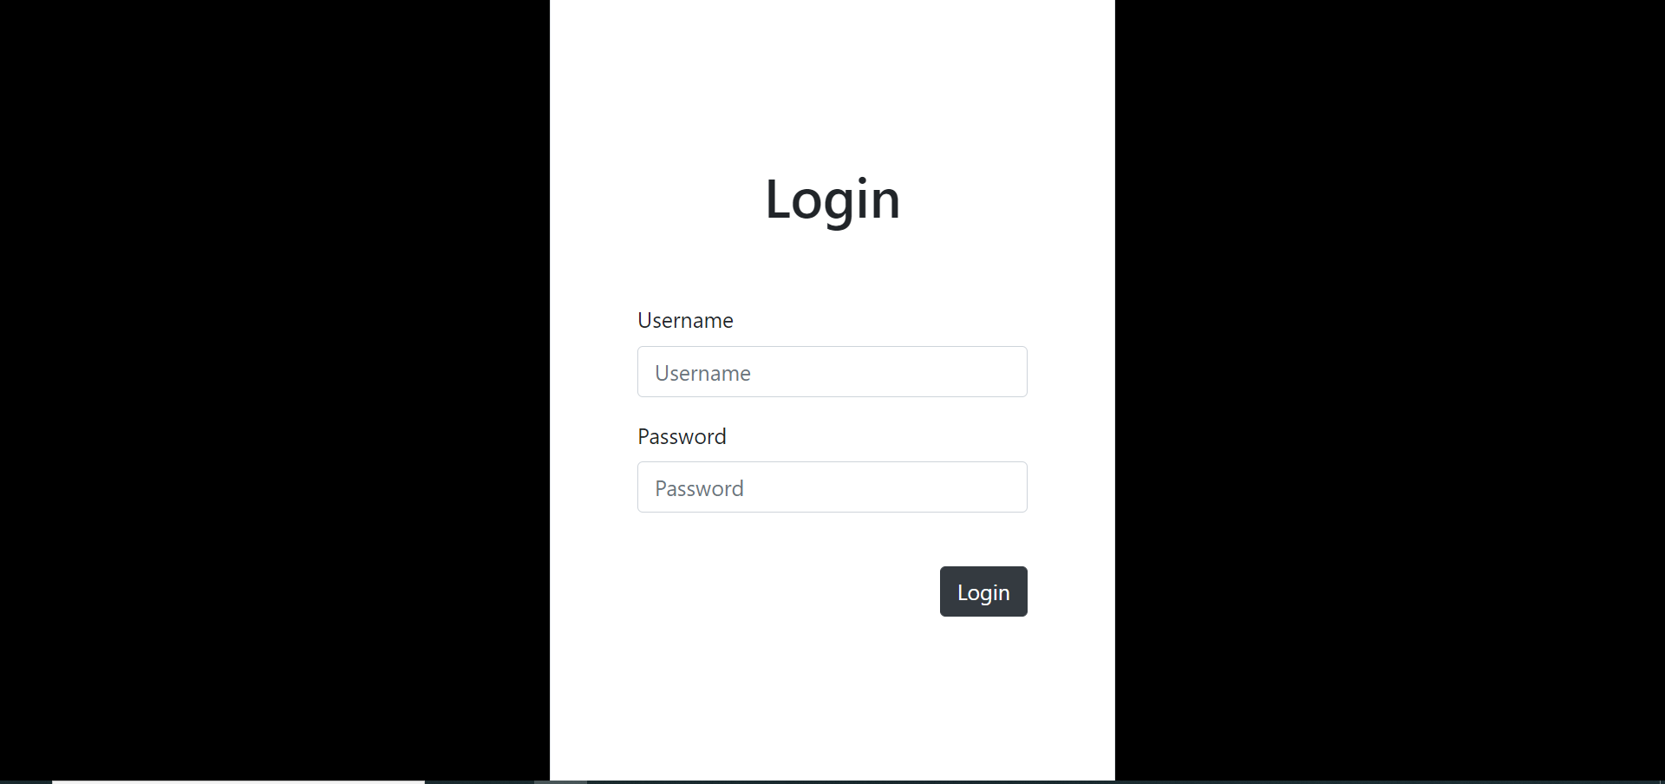
Figure 1 : Login page

  - Login as Admin
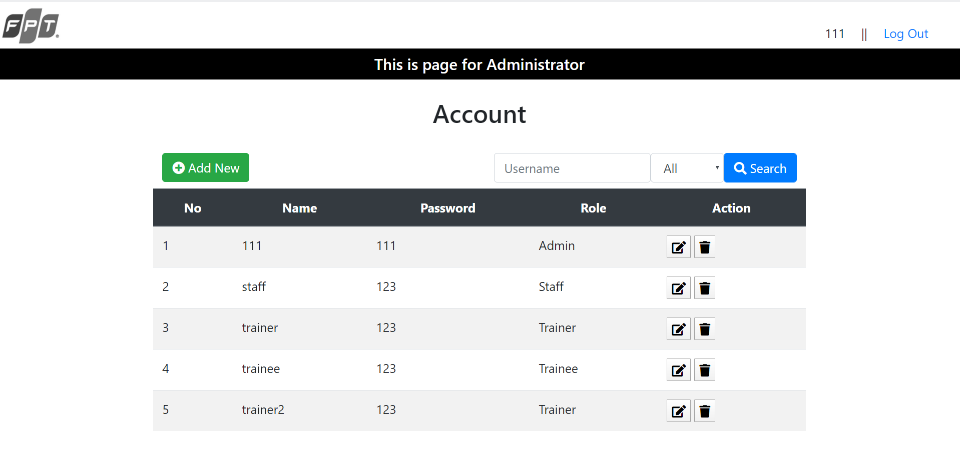
Figure 2 : The page show list of existing account
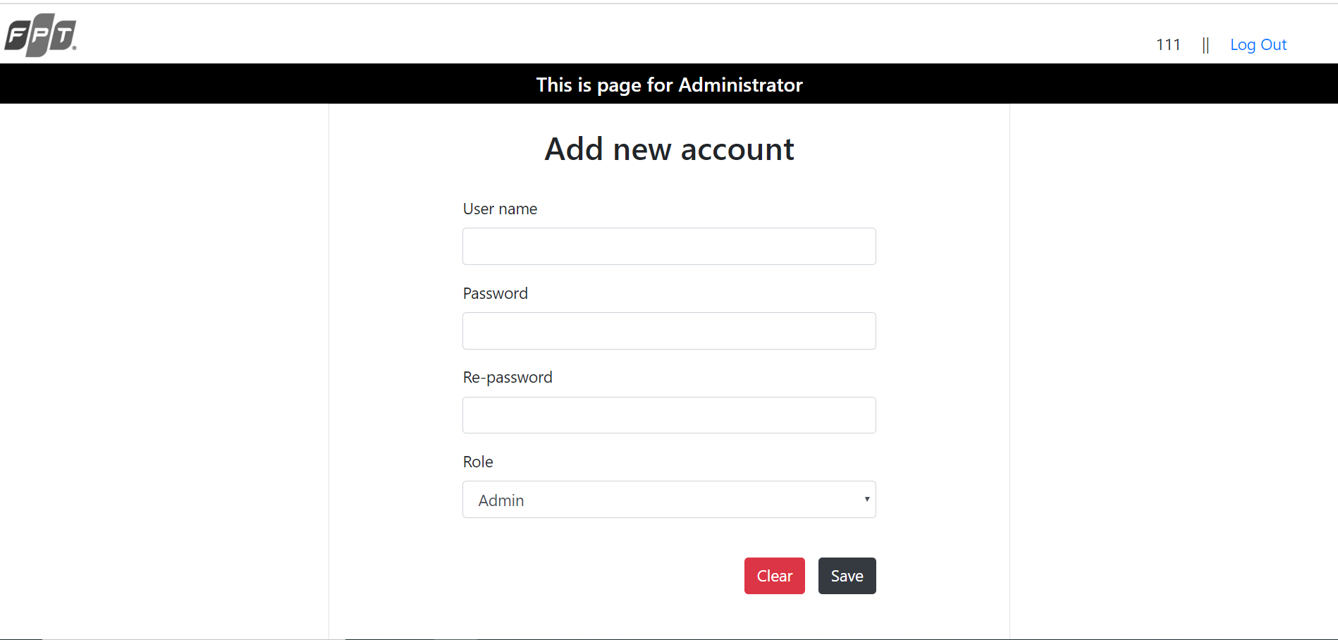
Figure 3 : The page for admin to add newt account
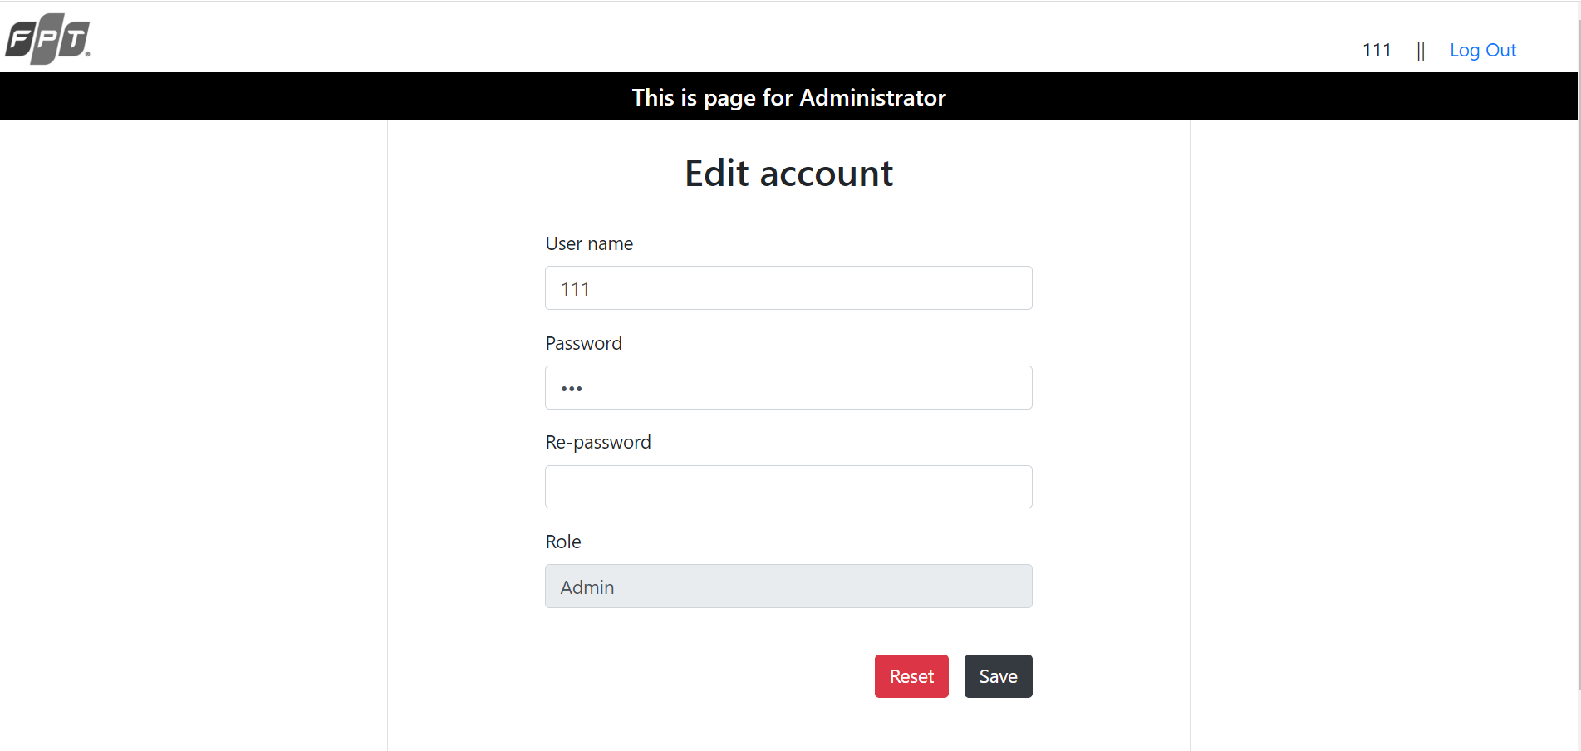
Figure 4 : The page for admin to edit account

  - Login as Training Staff
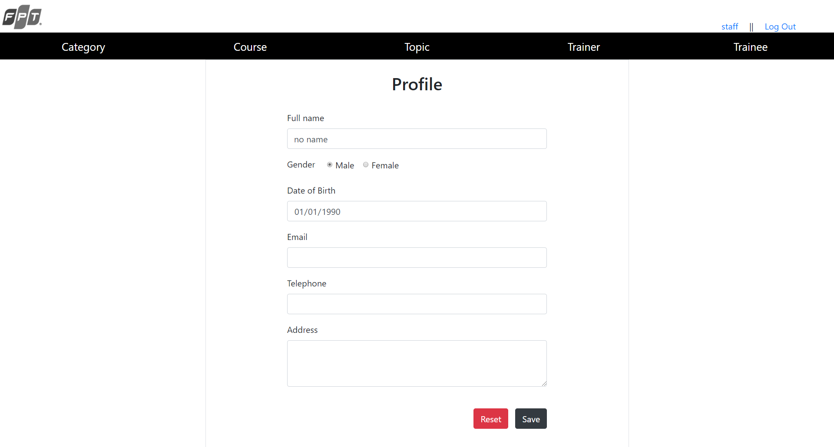
Figure 5 : The page for staff to edit their profile
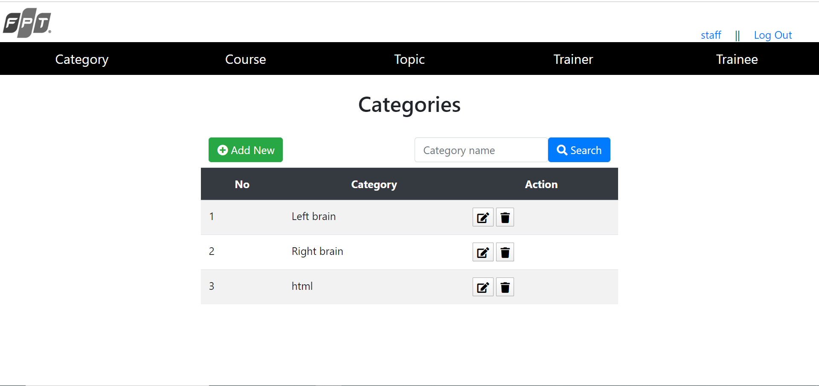
Figure 6 : The page show list of existing category

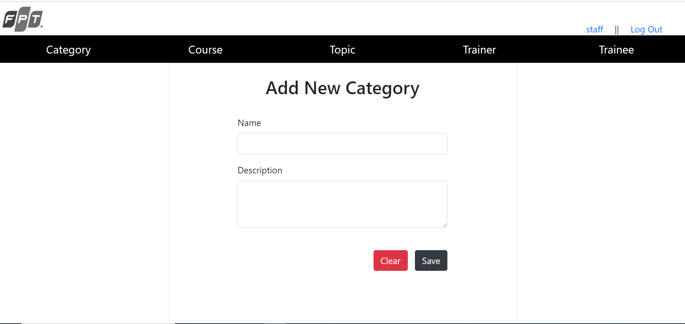
Figure 7 : The page for staff to add new category
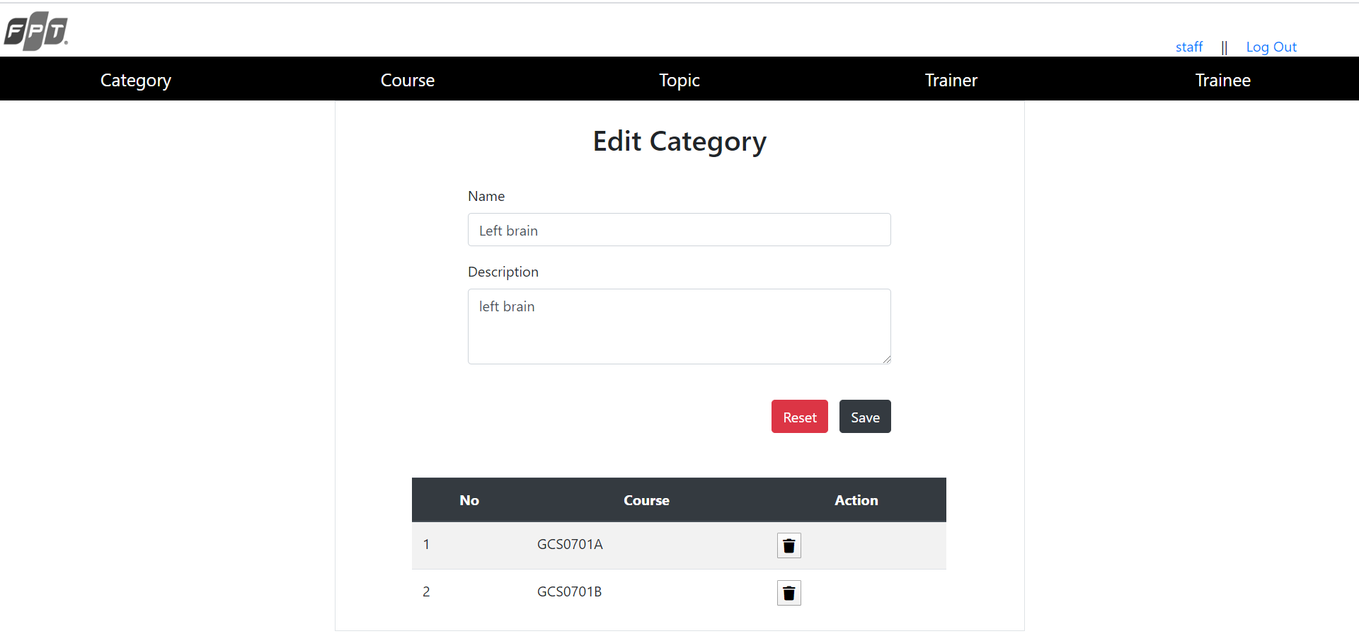
Figure 8 : The page for staff to edit category
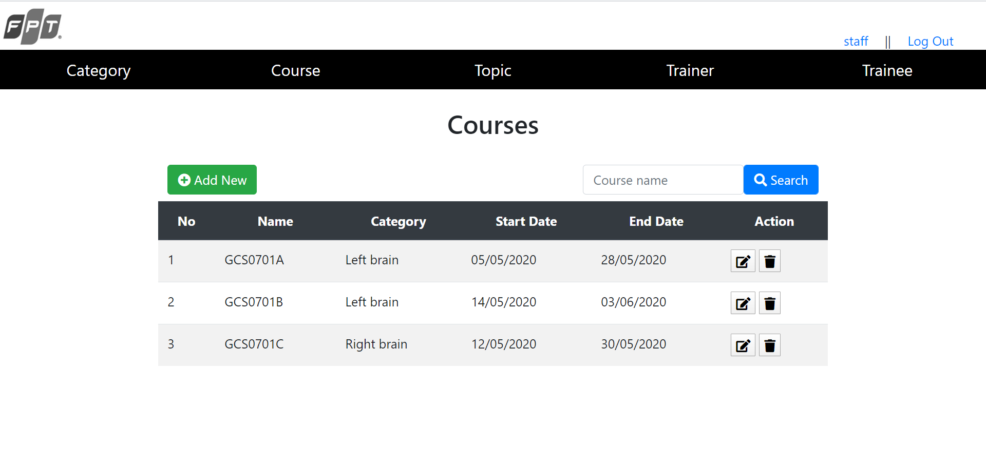
Figure 9 : The page show list of existing course

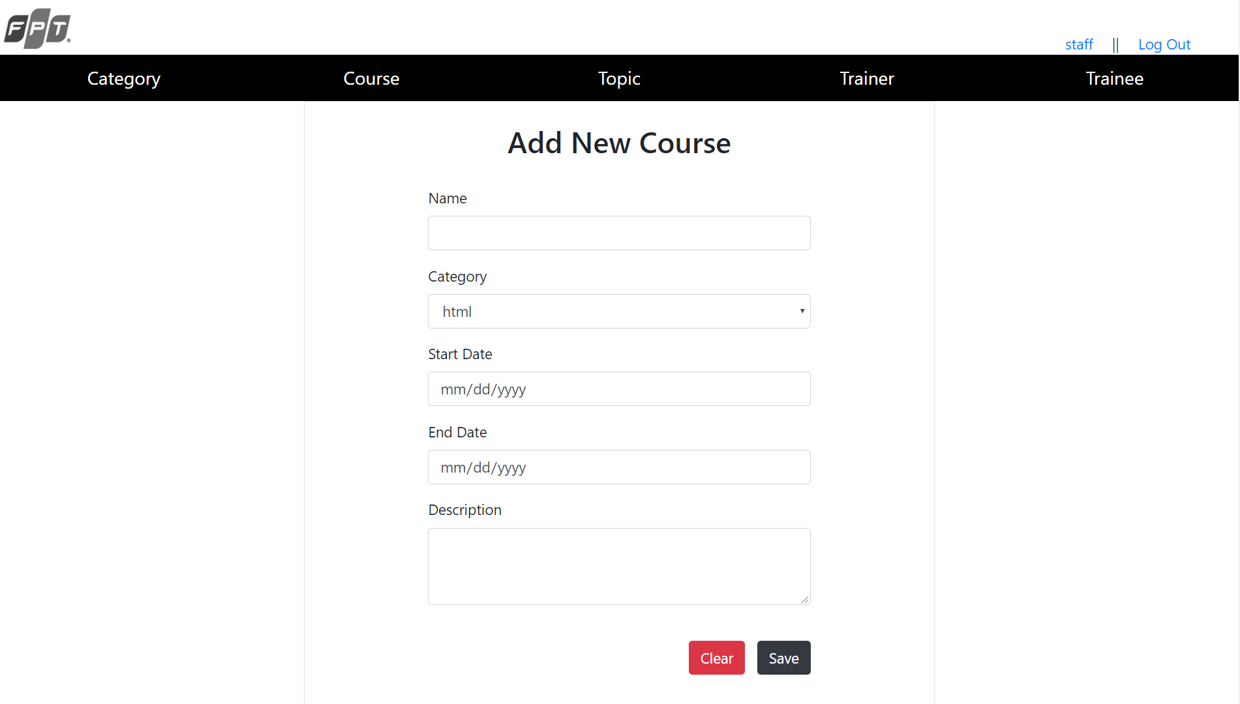
Figure 10 : The page for staff to add new course
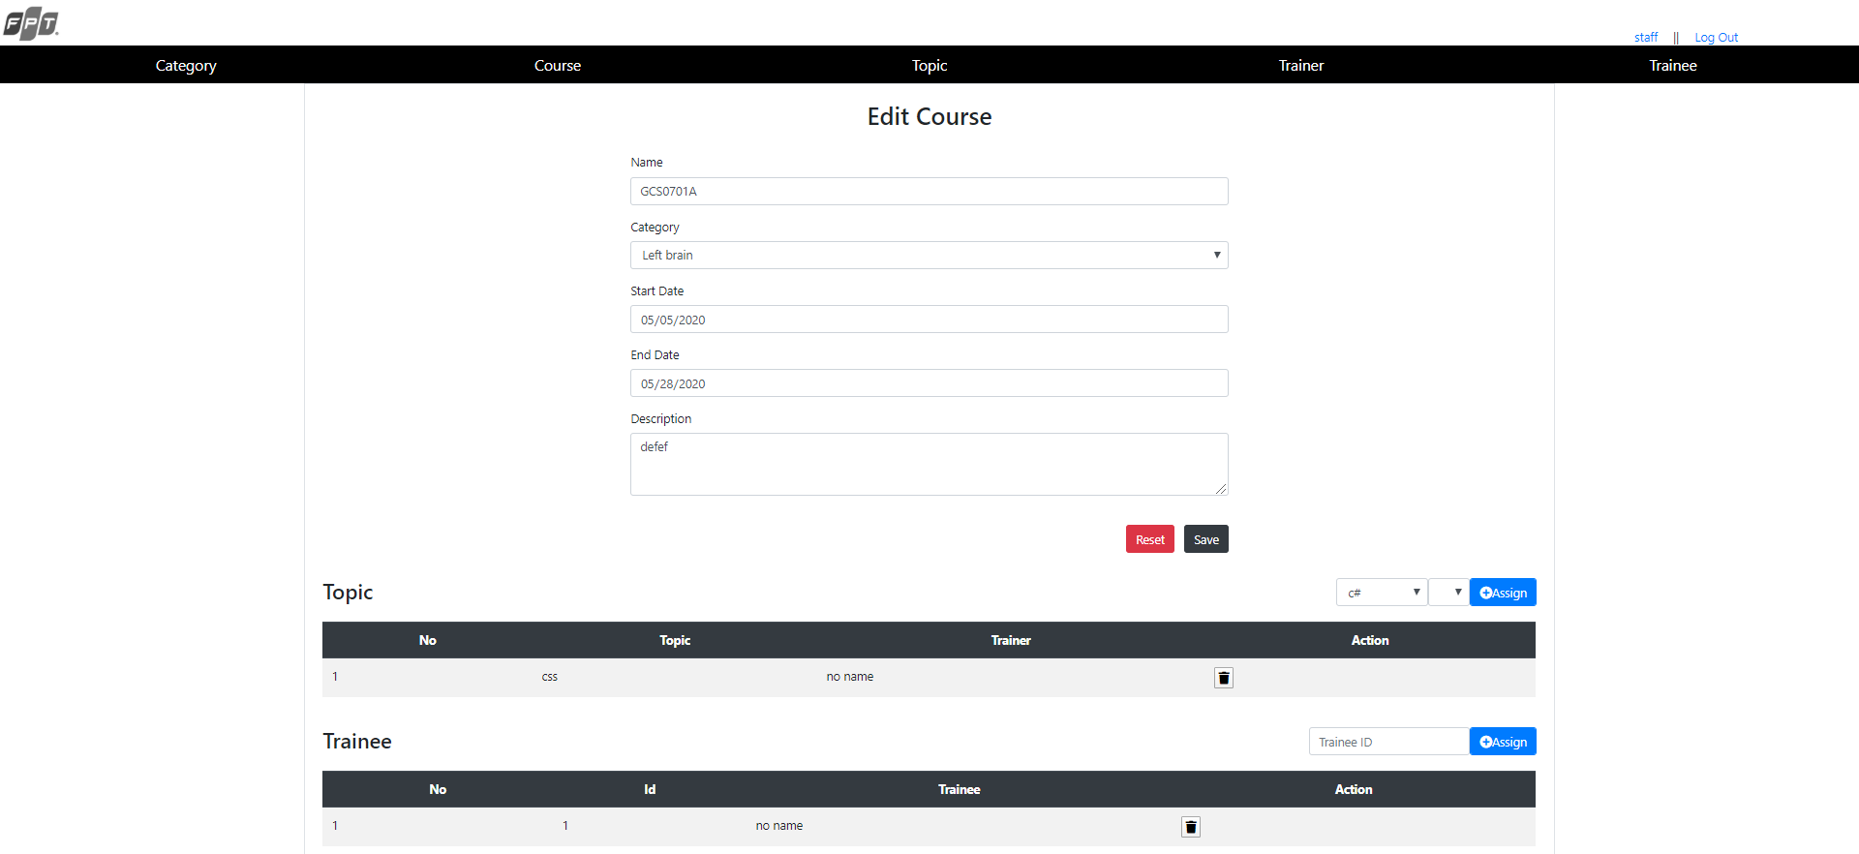
Figure 11 : The page for staff to edit course
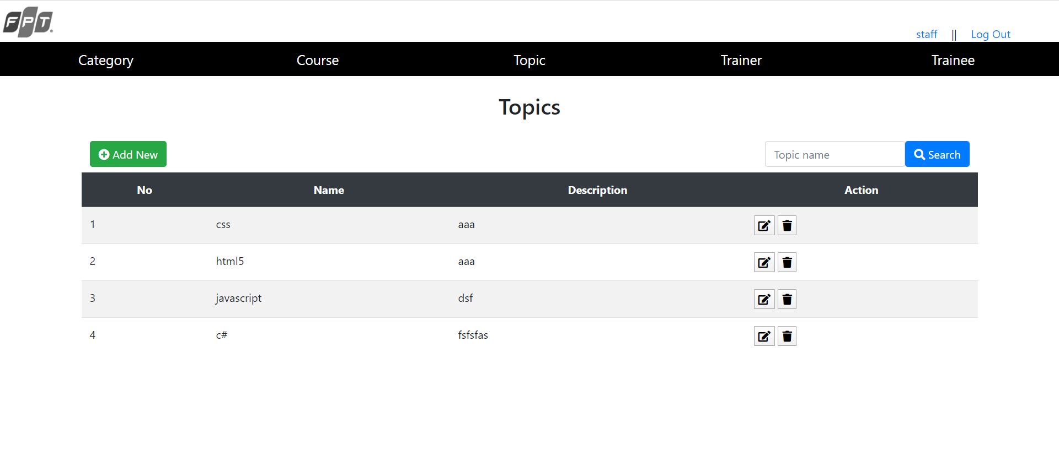
Figure 12 : The page show list of existing topic
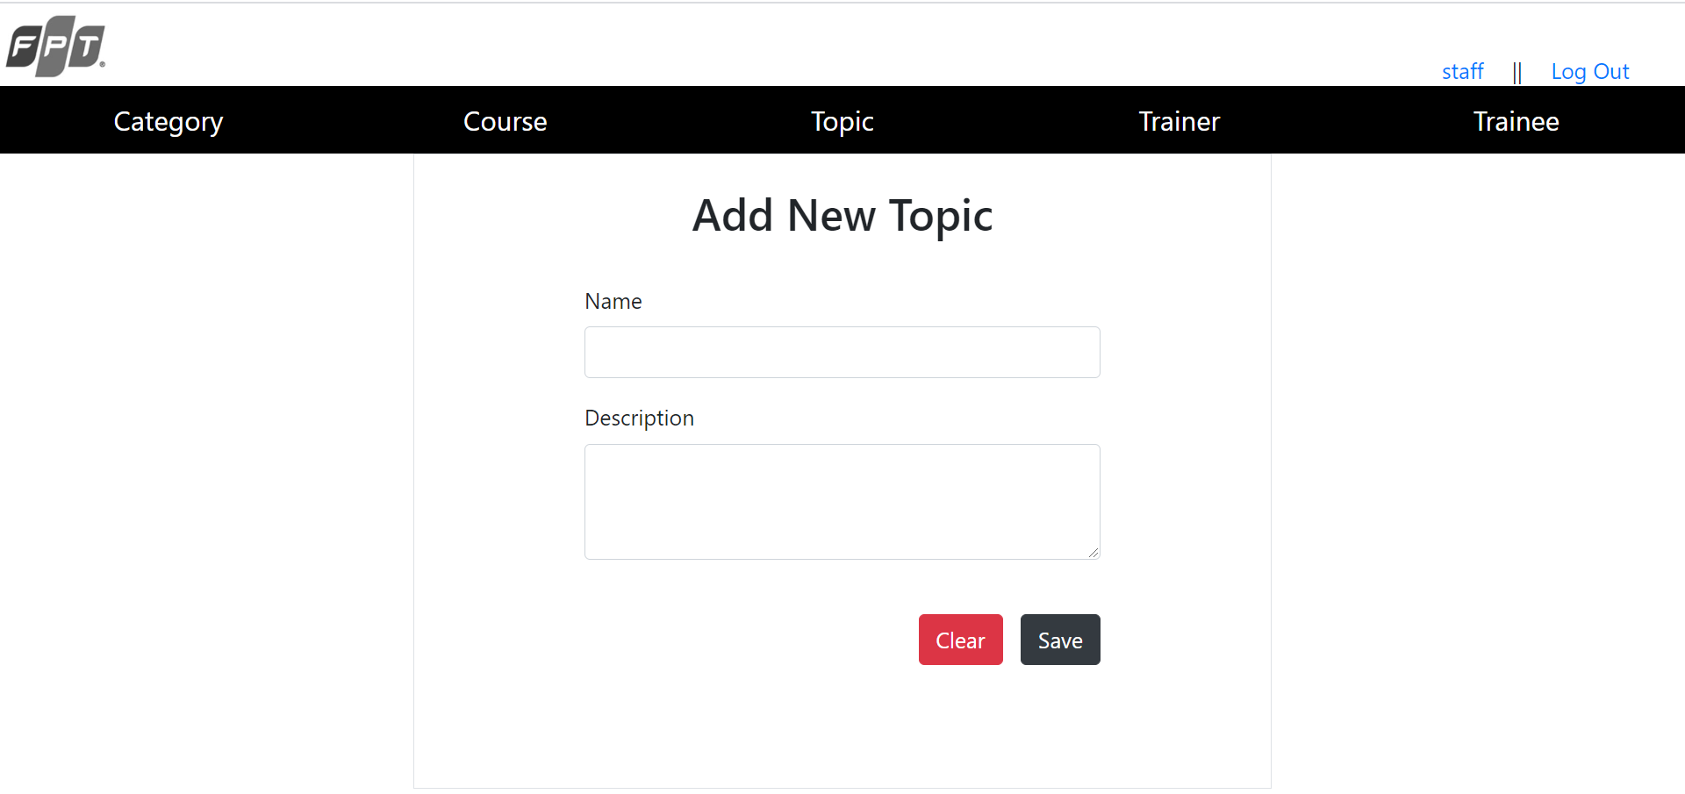
Figure 13 : The page for staff to add new topic
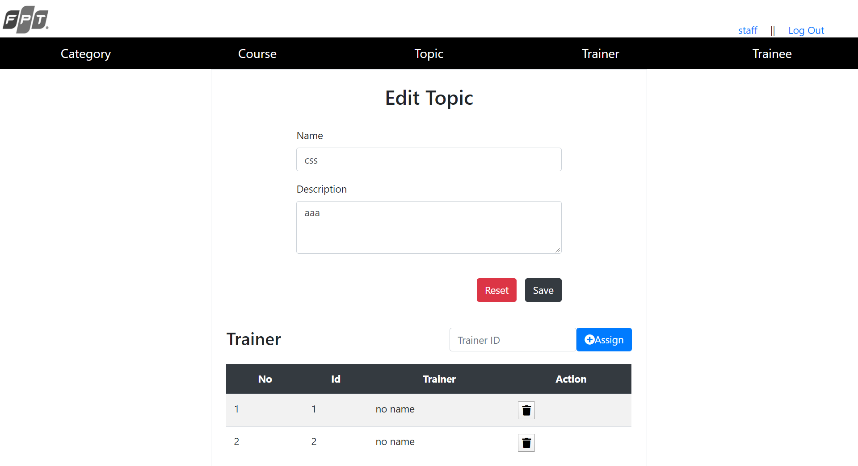
Figure 14 : The page for staff to edit topic
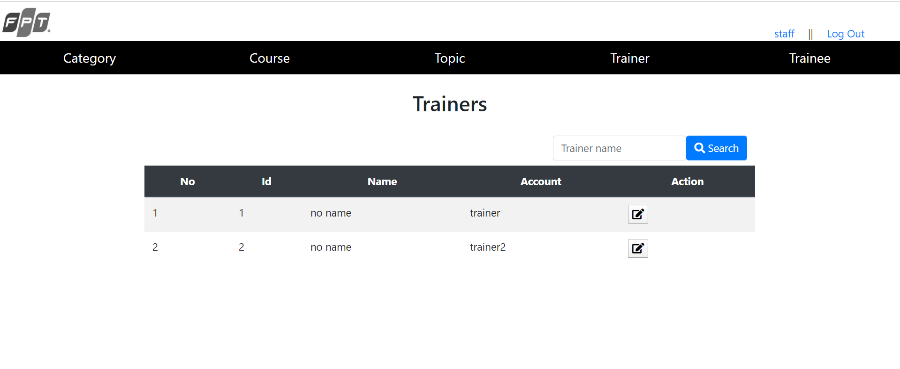
Figure 15 : The page show list of existing trainer

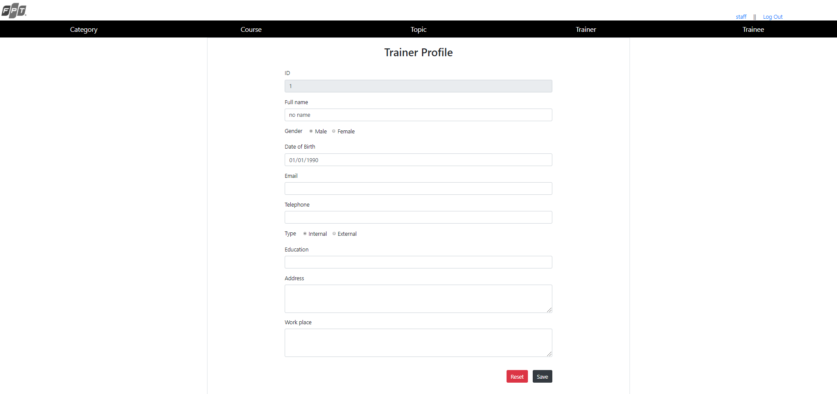
Figure 16 : The page for staff to edit trainer profile
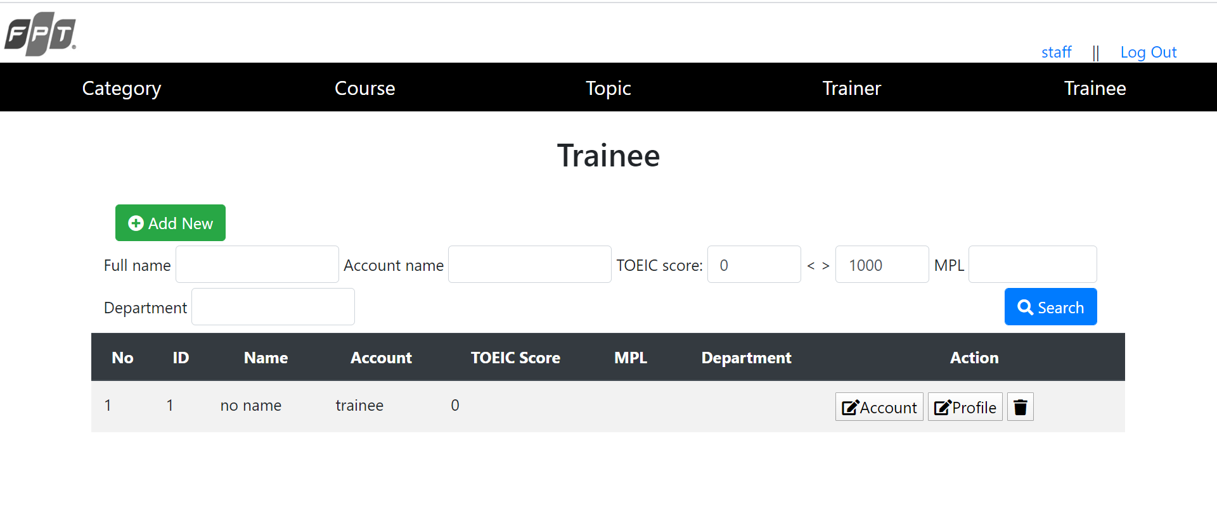
Figure 17: The page show list of existing trainee
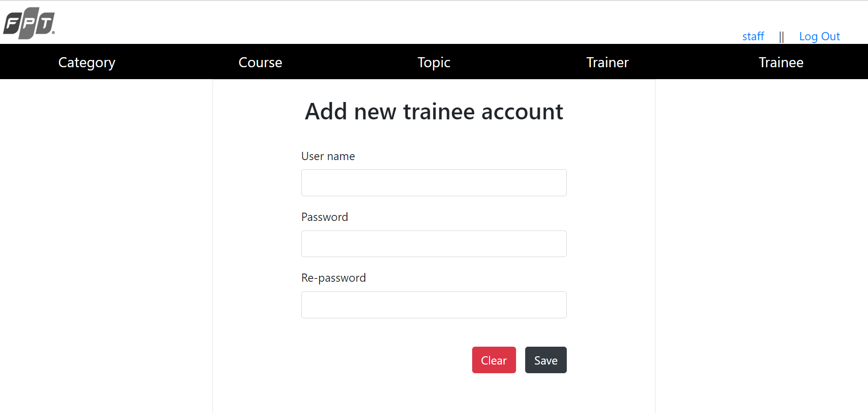
Figure 18 : The page for staff to add new trainee account

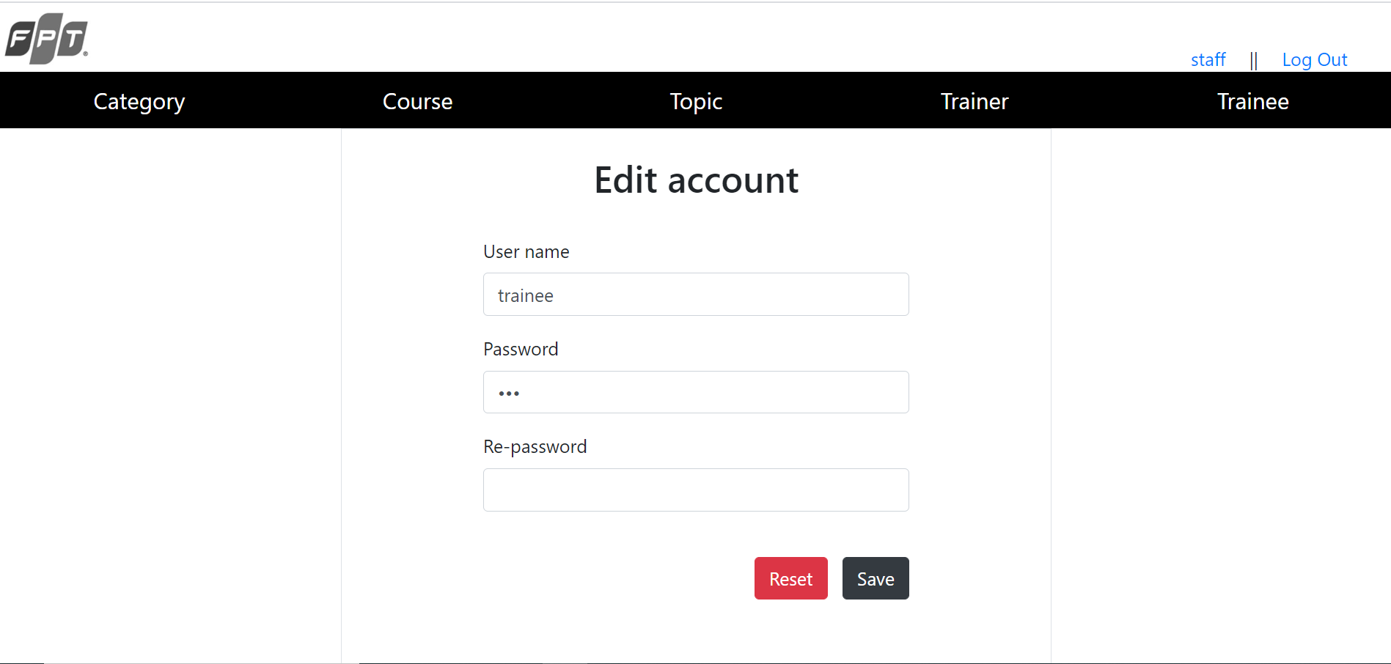
Figure 19 : The page for staff to edit trainee account

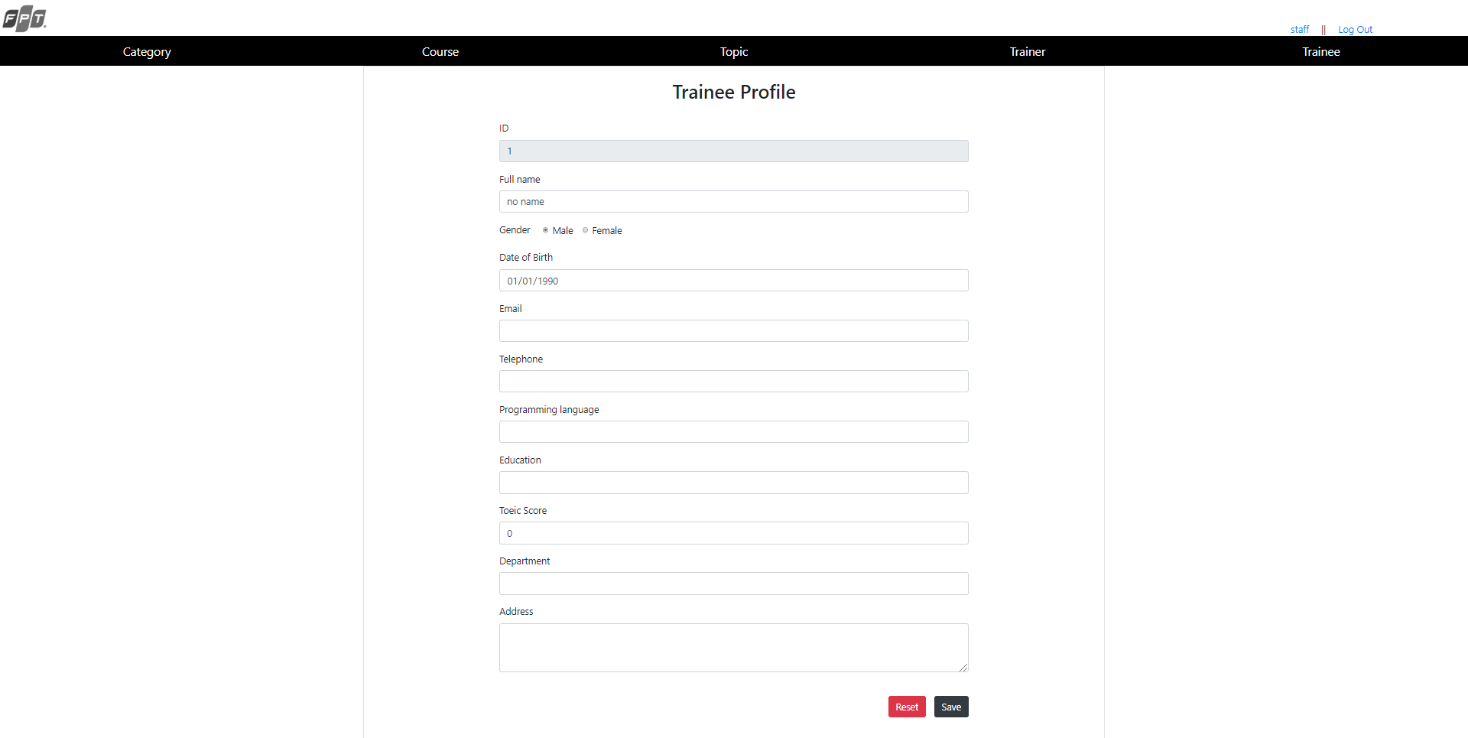
Figure 20 : The page for staff to edit trainee profile

  - Login as Trainer
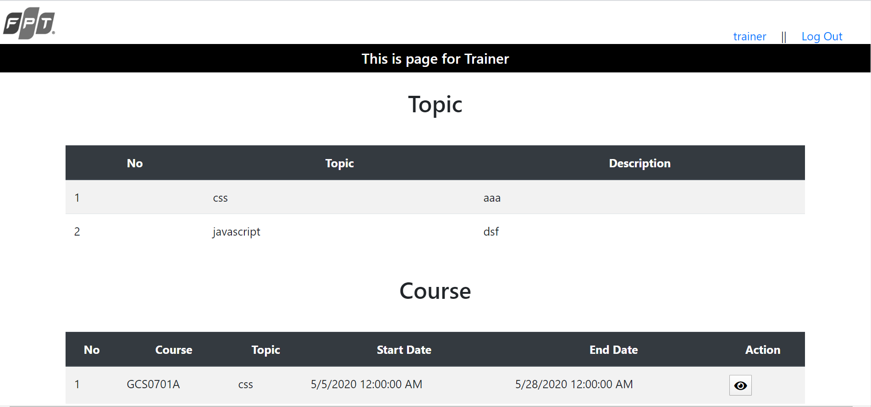
Figure 21 : The page show of assigned topics and courses of login trainer
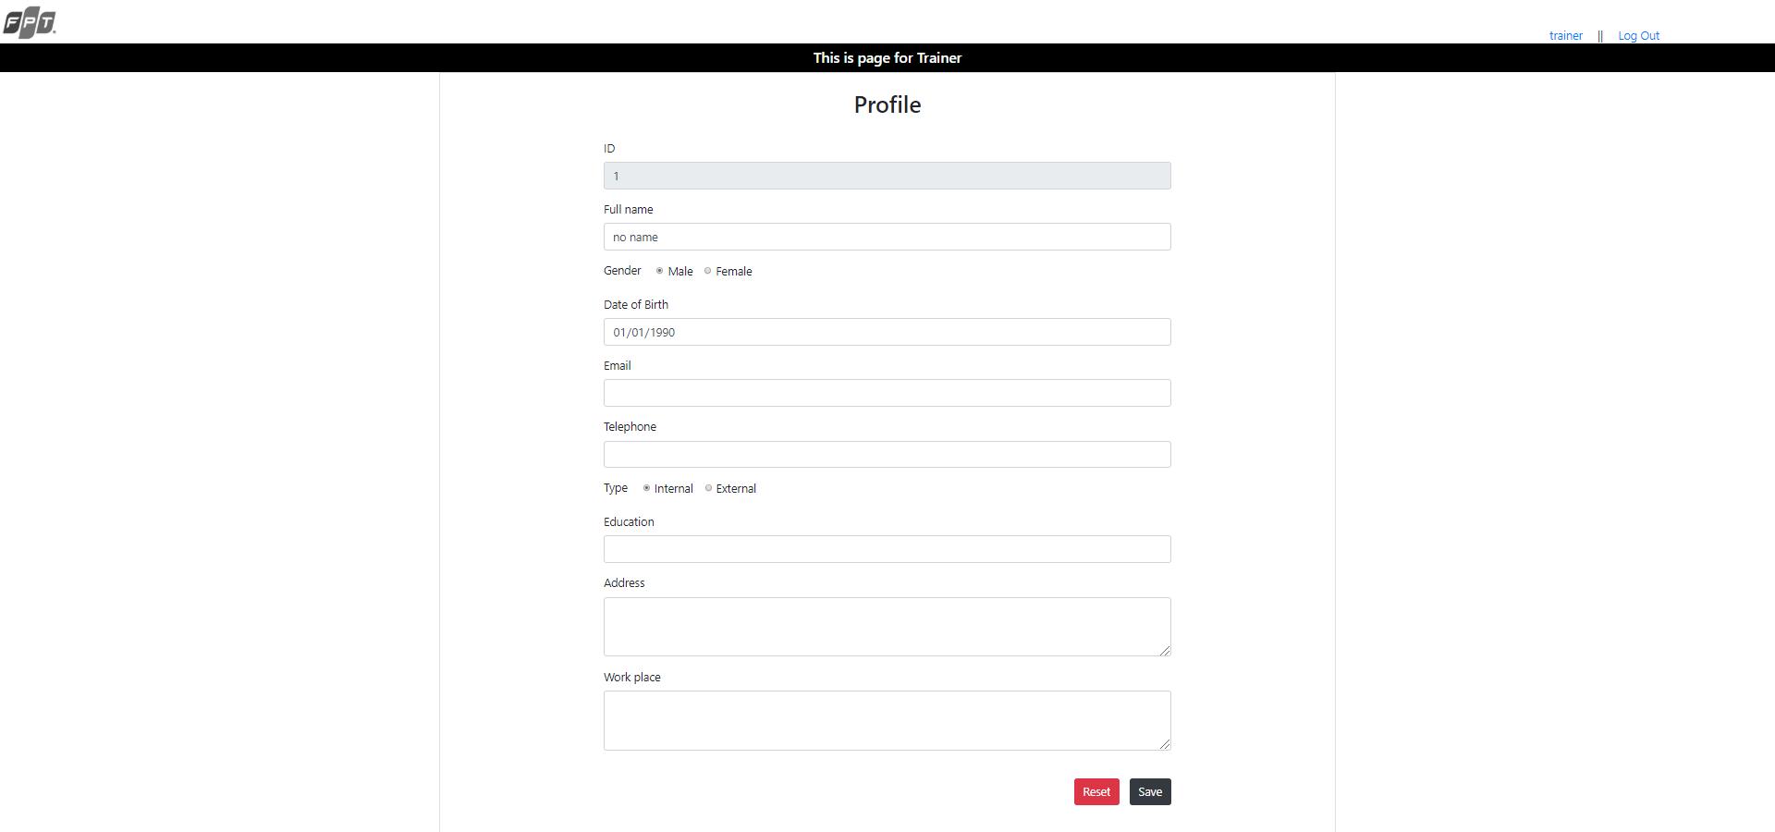
Figure 22 : The page for login trainer to edit their profile

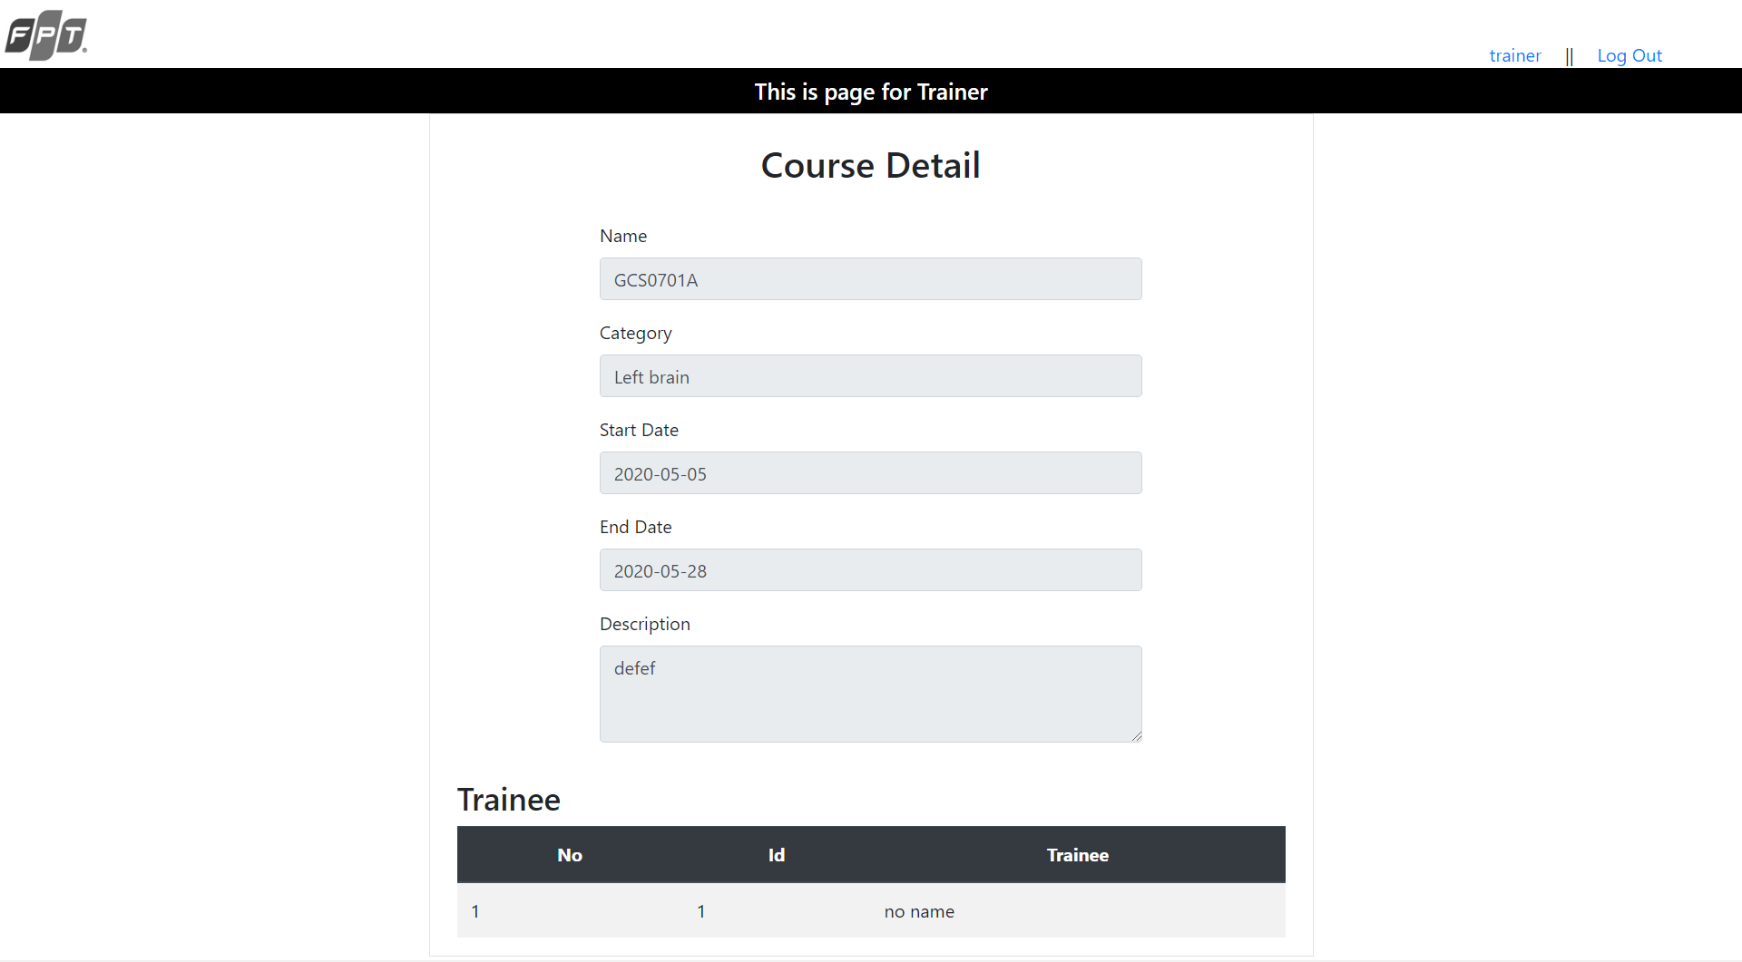
Figure 23 : The page show the detail of assigned course of login trainer

  - Login as Trainee
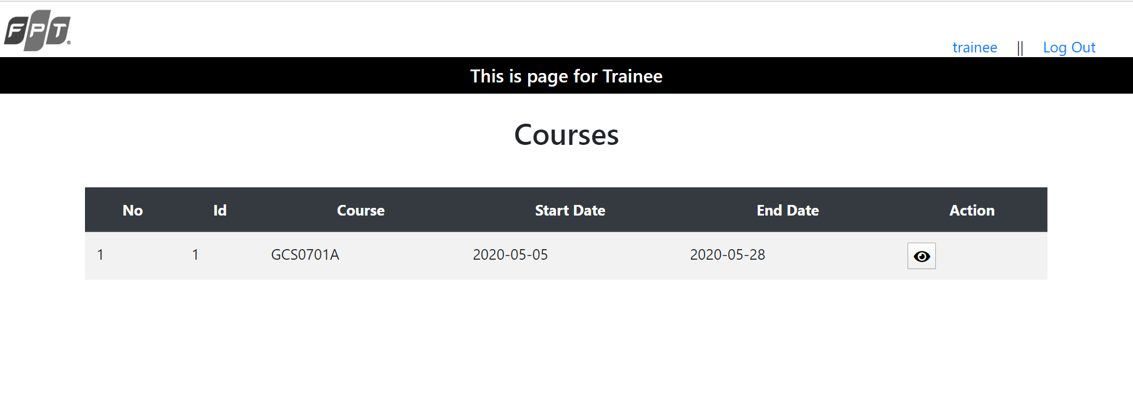
Figure 24 : The page show of assigned courses of login trainee
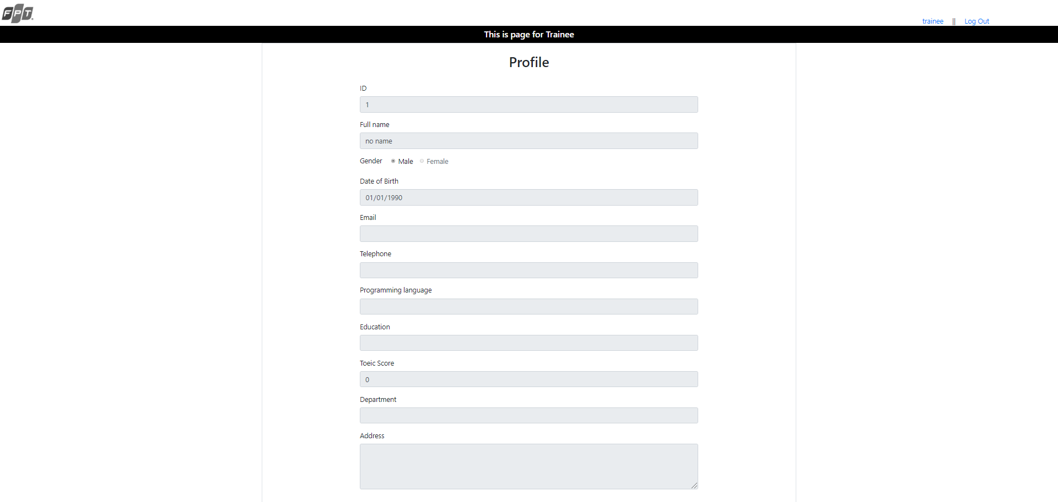
Figure 25 : The page show the profile of the login trainee

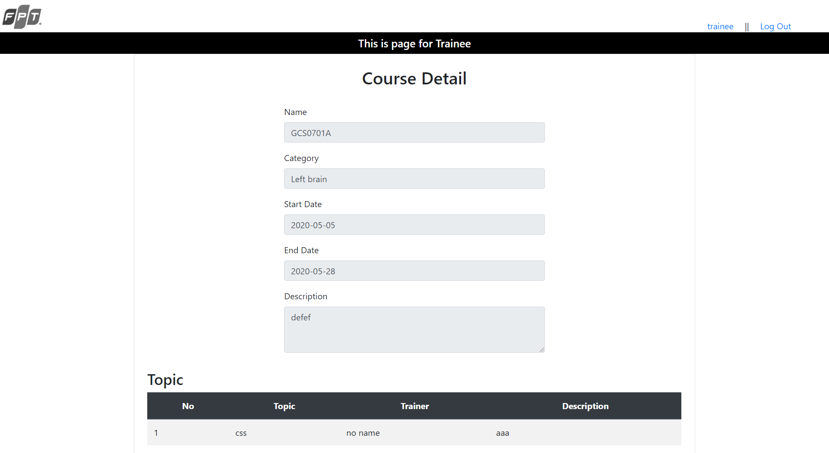
Figure 26 : The page show the detail of assigned course of login trainee

- Review performance
  - Test plan
- Admin
No | Task | Expected result
1 | Login as Admin | The application display websites for Admin after login with Admin account
2 | Search account via username | The application display list of account with the appropriate account with username which have the key words in search bar
3 | Edit username and password of an account | The username and password are modified after the action.
4 | Delete account | The specific account will be completely remote from the application database
5 | Log out | The application redirect to log in page and user can not go to other pages without re-login.

- Training Staff
No | Task | Expected result
1 | Login as Training Staff | The application display websites for Training Staff after login with Training Staff account
2 | Edit training staff profile | Training staff successfully edit his or her profile information
3 | Show list of category | The category index page show the list of category existed in the system.
4 | Search category via its name | The application display list of category with the appropriate name which have the key words in search bar
5 | Add new category | New category will be added into the system.
6 | Edit existing category information | Category information is modified after Training staff update it.
7 | Delete category | Category is completely deleted from the application.
8 | Remove course from category | Course will be removed from the course table which is display in the category edit page.
9 | Show list of course | The course index page show the list of course existed in the system.
10 | Search course via its name | The application display list of course with the appropriate name which have the key words in search bar
11 | Add new course | New course will be added into the system.
12 | Edit existing course information | Course information is modified after Training staff update it.
13 | Delete course | Course is completely deleted from the application.
14 | Assign Topic into course | The assigned topic will be display in the topic table in the course edit page
15 | Assign Trainee into course | The assigned trainee will be display in the trainee table in the course edit page
16 | Remove topic from course | Topic will be removed from the topic table which is display in the course edit page.
17 | Remove trainee from course | Trainee will be removed from the trainee table which is display in the course edit page.
18 | Show list of topic | The topic index page show the list of topic existed in the system.
19 | Search topic via its name | The application display list of topic with the appropriate name which have the key words in search bar
20 | Add new topic | New topic will be added into the system.
21 | Edit existing topic information | Topic information is modified after Training staff update it.
22 | Delete topic | Topic is completely deleted from the application.
23 | Assign Trainer into topic | The assigned trainer will be display in the trainer table in the topic edit page
24 | Remove trainer from topic | Trainer will be removed from the trainer table which is display in the topic edit page.
25 | Show list of trainer | The trainer index page show the list of trainer existed in the system.
26 | Search trainer via its name | The application display list of trainer with the appropriate name which have the key words in search bar
27 | Edit existing trainer information | Trainer information is modified after Training staff update it.
28 | Show list of trainee | The trainee index page show the list of trainee existed in the system.
29 | Search trainee via its name, account name, TOEIC score, and so on… | The application display list of trainee with the appropriate information which have the key words in search bar
30 | Add new trainee account | New trainee account will be added into the system.
31 | Edit existing trainee information | Trainee information is modified after Training staff update it.
32 | Edit existing trainee account | Trainee account username and password is modified after Training staff update it.

- Trainer
No | Task | Expected result
1 | Login as Trainer | The application display interface for Trainer after login with trainer account
2 | Show list of topic | The application display list of topic which the login trainer is assigned to
3 | Show list of course | The application display list of course which the login trainer is assigned to
4 | Edit profile | The login trainer information is modified after he or she update it.
5 | Show the detail of course | The application display the detail of a course and list of trainee who is assigned to it.

- Trainee

No | Task | Expected result
1 | Login as Trainee | The application display interface for Trainee after login with trainee account
2 | Show list of course | The application display list of course which the login trainee is assigned to
3 | Show the profile | The application display the profile information of the login trainee.
4 | Show the detail of course | The application display the detail of a course and list of topic which is assigned to it.

  - Test result
- Admin
No | Task | Result | Date | Error Description
1 | Login as Admin | Successful | 08/05/2020
2 | Search account via username | Successful | 08/05/2020
3 | Edit username and password of an account | Successful | 08/05/2020
4 | Delete account | Partial successful | 08/05/2020 | When the admin delete his or her own account, they still can use the application before they log out. The application should make them log out automatically.
5 | Log out | Successful | 08/05/2020

- Training Staff
No | Task | Result | Date | Error Description
1 | Login as Training Staff | Successful | 08/05/2020
2 | Edit training staff profile | Successful | 08/05/2020
3 | Show list of category | Successful | 09/05/2020
4 | Search category via its name | Successful | 09/05/2020
5 | Add new category | Successful | 09/05/2020
6 | Edit existing category information | Successful | 09/05/2020
7 | Delete category | Successful | 09/05/2020
8 | Remove course from category | Successful | 09/05/2020
9 | Show list of course | Successful | 09/05/2020
10 | Search course via its name | Successful | 09/05/2020
11 | Add new course | Successful | 09/05/2020
12 | Edit existing course information | Successful | 09/05/2020
13 | Delete course | Successful | 09/05/2020
14 | Assign Topic into course | Successful | 09/05/2020
15 | Assign Trainee into course | Successful | 09/05/2020
16 | Remove topic from course | Successful | 09/05/2020
17 | Remove trainee from course | Successful | 09/05/2020
18 | Show list of topic | Successful | 09/05/2020
19 | Search topic via its name | Successful | 09/05/2020
20 | Add new topic | Successful | 09/05/2020
21 | Edit existing topic information | Successful | 09/05/2020
22 | Delete topic | Successful | 09/05/2020
23 | Assign Trainer into topic | Successful | 09/05/2020
24 | Remove trainer from topic | Successful | 09/05/2020
25 | Show list of trainer | Successful | 09/05/2020
26 | Search trainer via its name | Successful | 09/05/2020
27 | Edit existing trainer information | Successful | 09/05/2020
28 | Show list of trainee | Successful | 09/05/2020
29 | Search trainee via its name, account name, TOEIC score, and so on… | Successful | 09/05/2020
30 | Add new trainee account | Successful | 09/05/2020
31 | Edit existing trainee information | Successful | 09/05/2020
32 | Edit existing trainee account | Successful | 09/05/2020

- Trainer
No | Task | Result | Date | Error Description
1 | Login as Trainer | Successful | 08/05/2020
2 | Show list of topic | Successful | 08/05/2020
3 | Show list of course | Successful | 08/05/2020
4 | Edit profile | Successful | 08/05/2020
5 | Show the detail of course | Successful | 08/05/2020

- Trainee
No | Task | Result | Date | Error Description
1 | Login as Trainee | Successful | 08/05/2020
2 | Show list of course | Successful | 08/05/2020
3 | Show the profile | Successful | 08/05/2020
4 | Show the detail of course | successful | 08/05/2020

References
- Entityframeworktutorial.net. 2020. Fluent API In Entity Framework 6. [online] Available at: <https://www.entityframeworktutorial.net/code-first/fluent-api-in-code-first.aspx> [Accessed 9 May 2020].
- Entityframeworktutorial.net. 2020. Configure One-To-One Relationship In Code First Entity Framework. [online] Available at: <https://www.entityframeworktutorial.net/code-first/configure-one-to-one-relationship-in-code-first.aspx> [Accessed 9 May 2020].
- Entityframeworktutorial.net. 2020. Configure One-To-Many Relationship In Entity Framework 6. [online] Available at: <https://www.entityframeworktutorial.net/code-first/configure-one-to-many-relationship-in-code-first.aspx> [Accessed 9 May 2020].
- Entityframeworktutorial.net. 2020. Configure Many-To-Many Relationship In Code First. [online] Available at: <https://www.entityframeworktutorial.net/code-first/configure-many-to-many-relationship-in-code-first.aspx> [Accessed 9 May 2020].
- Entityframeworktutorial.net. 2020. Cascade Delete In Entity Framework 6. [online] Available at: <https://www.entityframeworktutorial.net/code-first/cascade-delete-in-code-first.aspx> [Accessed 9 May 2020].
- Mark Otto, a., 2020. Tables. [online] Getbootstrap.com. Available at: <https://getbootstrap.com/docs/4.4/content/tables/> [Accessed 10 May 2020].
- Mcleod, S., 2020. Questionnaire: : Definition, Examples, Design And Types | Simply Psychology. [online] Simplypsychology.org. Available at: <https://www.simplypsychology.org/questionnaires.html> [Accessed 10 May 2020].
- Mark Otto, a., 2020. Grid System. [online] Getbootstrap.com. Available at: <https://getbootstrap.com/docs/4.1/layout/grid/> [Accessed 10 May 2020].
- application?, H., Gaotingwe, T., Enamno, J., Woodward, J., Maccaferri, L. and Sharma, M., 2020. How To Use Sessions In An ASP.NET MVC 4 Application?. [online] Stack Overflow. Available at: <https://stackoverflow.com/questions/14138872/how-to-use-sessions-in-an-asp-net-mvc-4-application> [Accessed 10 May 2020].
- js.foundation, J., 2020. Jquery.Ajax() | Jquery API Documentation. [online] Api.jquery.com. Available at: <https://api.jquery.com/jquery.ajax/> [Accessed 10 May 2020].

